Don’t read this review…Go straight out and buy 5-star epic fantasy The Jack of Souls

02MondayMar 2015

Posted by barbtaub in Author Interviews, Book Review, excerpts,Reviews, writing: craft
≈ 7 Comments
Tags
epic fantasy, excerpt,interview, review, rogue and knight, sci-fi fantasy, Stephen Merlino, The Jack of Souls

Blurb: A rogue knight and epic fantasy series begins
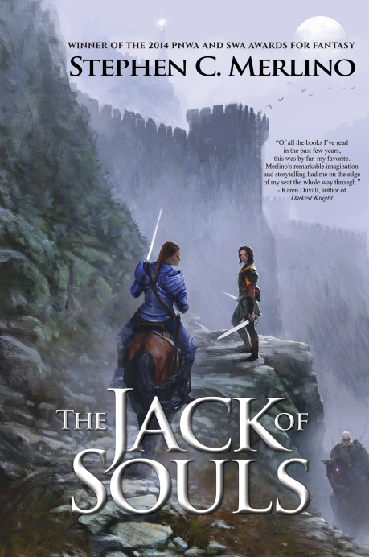
An outcast rogue must break a curse laid on his fate, or die by his next birthday. A tale of magic, mischief, and the triumph of tricksters.
Harric, an outcast rogue, must break a curse put on his fate, or die on his nineteenth birthday. As the day approaches, nightmares from the spirit world stalk and tear at his sanity; sorcery eats at his soul.
To survive, he’ll need more than his usual tricks. He’ll need help—and a lot of it—but on the kingdom’s lawless frontier, his only allies are other outcasts. One of these outcasts is Caris, a mysterious, horse-whispering runaway, intent upon becoming the Queen’s first female knight. The other is Sir Willard—ex-immortal, ex-champion, now addicted to pain-killing herbs and banished from the court. With their help, Harric might keep his curse at bay. But for how long?
And both companions bring perils and secrets of their own: Caris bears the scars of a troubled past that still hunts her; Willard is at war with the Old Ones, an order of insane immortal knights who once enslaved the kingdom. The Old Ones have returned to murder Willard and seize the throne from his queen. Willard is both on the run from them, and on one final, desperate quest to save her.
Together, Harric and his companions must overcome fanatical armies, murderous sorcerers, and powerful supernatural foes.
Alone, Harric must face the temptation of a forbidden magic that could break his curse, but cost him the only woman he’s ever loved.
- Book Title: The Jack of Souls (Book 1 of The Unseen Moon series)
- Author: Stephen Merlino
- Genre: Rogue and Knight Epic Fantasy
- Length: 352 pages
- Release Date: December 20, 2014 (Tortoise Rampant Press)

My review: 5 out of 5 stars for The Jack of Souls: Book 1 of The Unseen Moon series by Stephen C. Merlino
That moment. You know the one… you’ve just read the last page of the last book of your current series-obsession, the one that has been the answer to every spare moment since… hmm… Now what? You’ve read all ten volumes of The Belgariad (okay, and all six of The Elenium). You’ve worn out your box set of LOTR, not to mention watched every one of the movies (extended version). You’ve even (shudder) found yourself thinking it might not be so bad to watch the entireHarry Potter series again. Sherlock has barely started filming Series 4. Your sister reminds you—yet again—that you could borrow all three volumes of herFifty Shades set. And you um… might just have already memorized every line ofFirefly. Who you gonna call?
Do not despair: I have good news! No…great news. Because Stephen Merlino has released The Jack of Souls, Book 1 of The Unseen Moon Series. And it’s the perfect epic fantasy. So why waste another moment reading this review, when you could be downloading the first volume of your brand new obsession?
Still reading? Seriously? Okay, I guess I could mention how Merlino takes every one of the sacred tenets of epic fantasy consecrated by patron saint J.R.R. Tolkien, paying loving homage even as he turns the genre sideways and makes it his bitch:
- Mystical hero from the past gathering a small band of Heroes, Simple Folk, and (probably) Lost Heir to the throne? Well, there is Sir Willard, who is no longer immortal, but is in fact…old. (“Used to eat whatever the Black Moon I wanted. Now it’s oats, or look out.”). His little band includes Harric—an outcast trickster whose (dead) mother is trying to kill him and whose girlfriend, Caris—a gifted student warrior whose magical connection to horses often leaves her unable to function in human terms—refuses to have anything to do with tricksters.
- Hobbit? Of course there’s Brolli—a magic-wielding chimp-like other.
- Super cool sword and horse? Sir Willard’s sword Belle is still as sharp as ever, not to mention Molly—his immortal, bad-tempered, magic horse.
- Dark force from the dark past returning for (unspecified) dark purpose? The villains in The Jack of Souls are really, really dark, with the most powerful and insane barely under the control of their deviously evil masters. But here’s the thing about all these old magic-using types—they’re all in Arkendia, a land whose god has given them three fundamental rules: “Let none of you worship or pray gods for favors, Nor bow down to high lords among you. Neither rely you on magic, and you shall be strong.” So—no gods, no high lords, and most especially no magic. Their favorite oath is “Gods leave me.” It’s kind of an uphill slog for the forces of evil.
- One ring to rule them all? There was going to be one, but the Queen got really annoyed at the implication that she needed a man, and then it accidentally got stuck on Caris’ hand, and… well the whole ring-thing is kind of a mess.
The Jack of Souls is a tribute to the Trickster, an exhilarating and funny and larger-than-life paen to the ones who might not be the strongest or bravest, but can out-think, outlast, or outplay their musclebound foes. It’s a lightning-paced rollercoaster world built of humor, bravery, brains, and excellent writing. The villains are unequivocally evil. The heroes are flawed, hexed, unlucky, or just plain old. And sometimes they smell really bad.
Are you really still reading this? I’m not kidding. Do yourself a favor now and grab a copy of The Jack of Souls. I’d give it five stars without question, and put Stephen Merlino on an auto-buy preorder for all future books. The Jack of Soulsis just that good.
**I received this book for free from the publisher or author in exchange for an honest review. This does not affect my opinion of the book or the content of my review.**

Excerpt
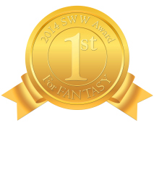
First Place for Fantasy: 2014 Southwest Writers International Competitionhttp://www.southwestwriters.com/contest/sww-annual-international-writing-contest/2014-contest-winners/
First Place for Fantasy: 2014 Pacific Northwest Writers Association International Literary Competitionhttp://www.pnwa.org/?page=2014contestwinners
Excerpt from The Jack of Souls
Somewhere in the room, Lyla gasped.
Harric tried in vain to locate her in the dim wreckage of the bunks. Run, now! he wanted to whisper. He falls asleep! Go! But Sir Bannus’s crushing grip left him almost no breath to speak.
A movement in the darkness beside Bannus. Lyla! Harric motioned frantically for her to flee.
Bannus’s head jerked. The mad eyes found Harric. The fist tightened on Harric’s shirt until it seemed Harric’s ribs would pop, and his head began to ring. Run, Lyla…
White flashes raced before his eyes. His body heaved upward. His head whipped to the side, and his face grew heavy with blood.
Distantly, he experienced the sensation of flying.

